Nama : Muhammad Ridho

Kelas : 4IA06

NPM : 51421055

Materi : Implementasi Aspect Oriented Programming (AOP) dan Dependency injection pada Project Spring dan Hibernate.

Mata Praktikum : Rekayasa Perangkat Lunak 2

ACTIVITY 6

SOAL

1. Screenshoot hasil codingan kalian lengkap dengan window Projects, Navigator, dan Outputnya.

JAWABAN

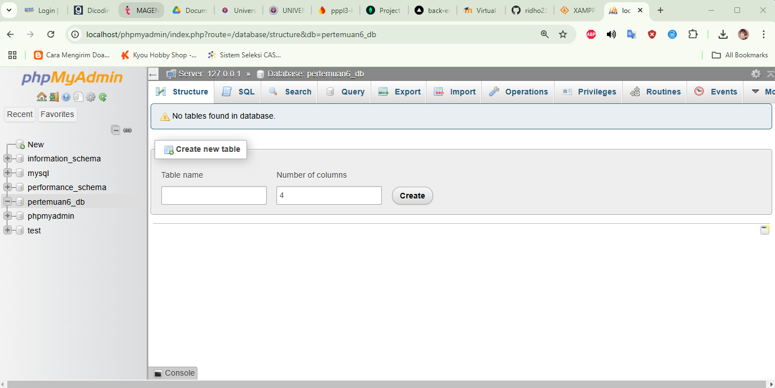

**Pom.xml**

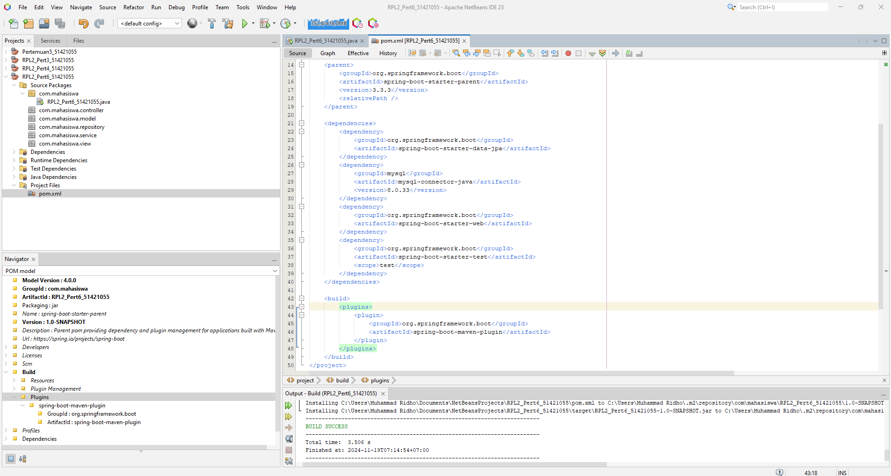

**ModelMahasiswa.java**

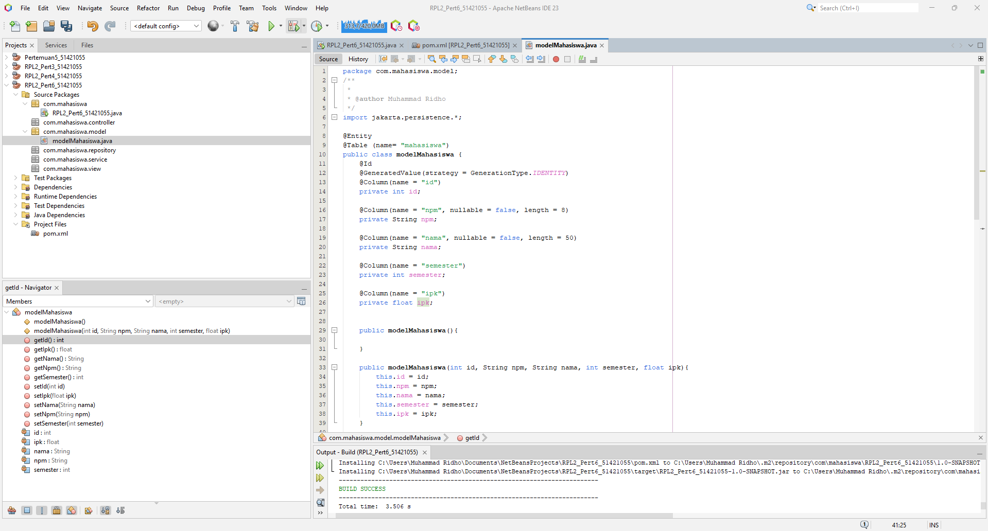

*Sourcecode:*

*package com.mahasiswa.model;*

*/\*\**

*\**

*\* @author Muhammad Ridho*

*\*/*

*import jakarta.persistence.*;*

*@Entity*

*@Table (name= "mahasiswa")*

*public class modelMahasiswa {*

*@Id*

*@GeneratedValue(strategy = GenerationType.IDENTITY)*

*@Column(name = "id")*

*private int id;*

*@Column(name = "npm", nullable = false, length = 8)*

*private String npm;*

*@Column(name = "nama", nullable = false, length = 50)*

*private String nama;*

*@Column(name = "semester")*

*private int semester;*

*@Column(name = "ipk")*

*private float ipk;*

*public modelMahasiswa(){*

*}*

*public modelMahasiswa(int id, String npm, String nama, int semester, float ipk){*

*this.id = id;*

*this.npm = npm;*

*this.nama = nama;*

*this.semester = semester;*

*this.ipk = ipk;*

*}*

*public int getId() {*

*return id;*

*}*

*public void setId(int id) {*

*this.id = id;*

*}*

*public String getNpm() {*

*return npm;*

*}*

*public void setNpm(String npm) {*

*this.npm = npm;*

*}*

*public String getNama() {*

*return nama;*

*}*

*public void setNama(String nama) {*

*this.nama = nama;*

*}*

*public int getSemester() {*

*return semester;*

*}*

*public void setSemester(int semester) {*

*this.semester = semester;*

*}*

*public float getIpk() {*

*return ipk;*

*}*

*public void setIpk(float ipk) {*

*this.ipk = ipk;*

*}*

*}*

**ModelTableMahasiswa.java**

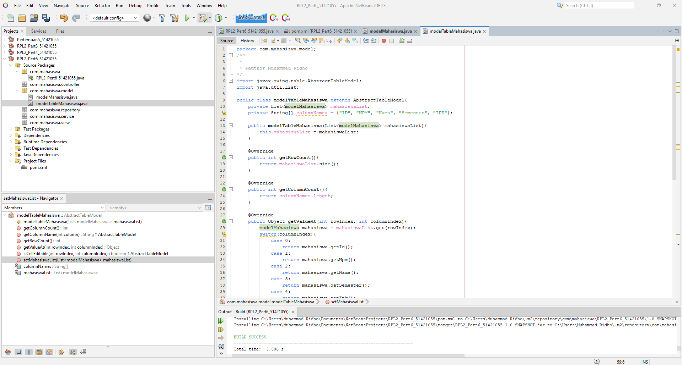

*Sourcecode:*

*package com.mahasiswa.model;*

*/\*\**

*\**

*\* @author Muhammad Ridho*

*\*/*

*import javax.swing.table.AbstractTableModel;*

*import java.util.List;*

*public class modelTableMahasiswa extends AbstractTableModel{*

*private List<modelMahasiswa> mahasiswaList;*

*private String[] columnNames = {"ID", "NPM", "Nama", "Semester", "IPK"};*

*public modelTableMahasiswa(List<modelMahasiswa> mahasiswaList){*

*this.mahasiswaList = mahasiswaList;*

*}*

*@Override*

*public int getRowCount(){*

*return mahasiswaList.size();*

*}*

*@Override*

*public int getColumnCount(){*

*return columnNames.length;*

*}*

*@Override*

*public Object getValueAt(int rowIndex, int columnIndex){*

*modelMahasiswa mahasiswa = mahasiswaList.get(rowIndex);*

*switch(columnIndex){*

*case 0:*

*return mahasiswa.getId();*

*case 1:*

*return mahasiswa.getNpm();*

*case 2:*

*return mahasiswa.getNama();*

*case 3:*

*return mahasiswa.getSemester();*

*case 4:*

*return mahasiswa.getIpk();*

*default:*

*return null;*

*}*

*}*

*@Override*

*public String getColumnName(int column){*

*return columnNames[column];*

*}*

*@Override*

*public boolean isCellEditable(int rowIndex, int columnIndex){*

*return false;*

*}*

*public void setMahasiswaList(List<modelMahasiswa> mahasiswaList){*

*this.mahasiswaList = mahasiswaList;*

*fireTableDataChanged();*

*}*

*}*

**mahasiswaRepository.java**

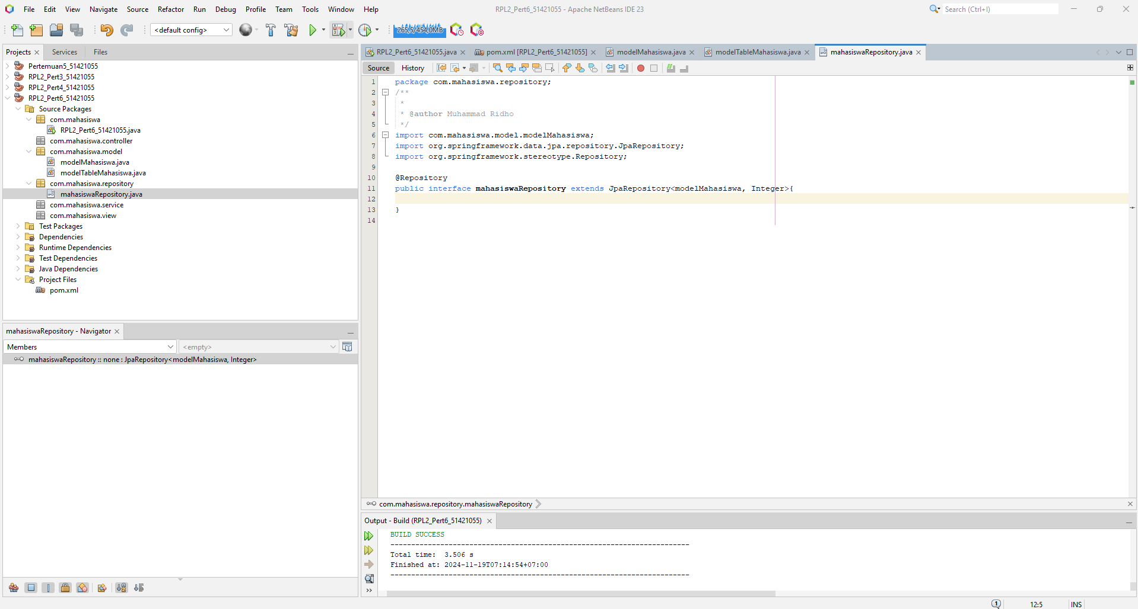

*Sourcecode:*

*package com.mahasiswa.repository;*

*/\*\**

*\**

*\* @author Muhammad Ridho*

*\*/*

*import com.mahasiswa.model.modelMahasiswa;*

*import org.springframework.data.jpa.repository.JpaRepository;*

*import org.springframework.stereotype.Repository;*

*@Repository*

*public interface mahasiswaRepository extends JpaRepository<modelMahasiswa, Integer>{*

*}*

**mahasiswaService.java**

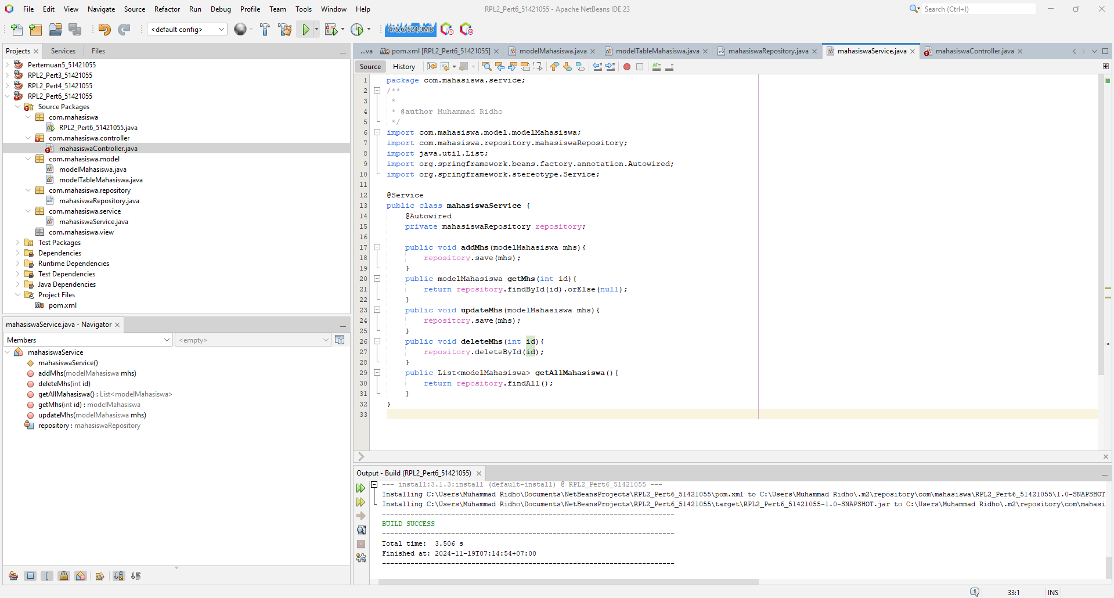

*Sourcecode:*

*package com.mahasiswa.service;*

*/\*\**

*\**

*\* @author Muhammad Ridho*

*\*/*

*import com.mahasiswa.model.modelMahasiswa;*

*import com.mahasiswa.repository.mahasiswaRepository;*

*import java.util.List;*

*import org.springframework.beans.factory.annotation.Autowired;*

*import org.springframework.stereotype.Service;*

*@Service*

*public class mahasiswaService {*

*@Autowired*

*private mahasiswaRepository repository;*

*public void addMhs(modelMahasiswa mhs){*

*repository.save(mhs);*

*}*

*public modelMahasiswa getMhs(int id){*

*return repository.findById(id).orElse(null);*

*}*

*public void updateMhs(modelMahasiswa mhs){*

*repository.save(mhs);*

*}*

*public void deleteMhs(int id){*

*repository.deleteById(id);*

*}*

*public List<modelMahasiswa> getAllMahasiswa(){*

*return repository.findAll();*

*}*

*}*

**mahasiswaController.java**

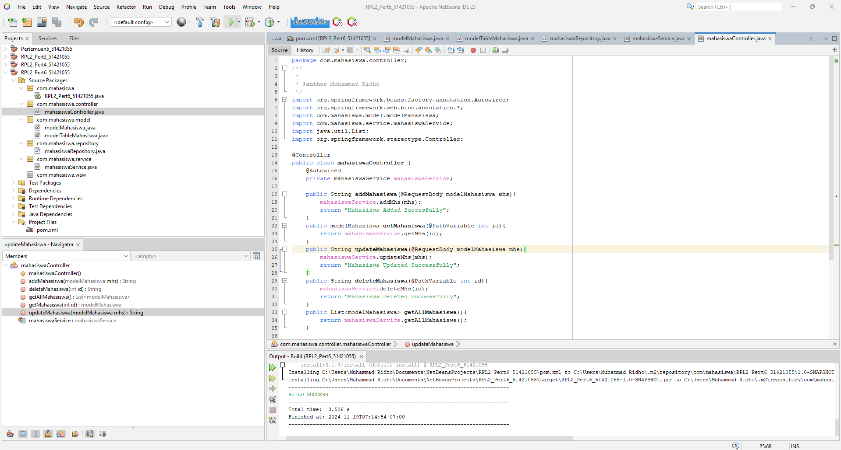

*Sourcecode:*

*package com.mahasiswa.controller;*

*/\*\**

*\**

*\* @author Muhammad Ridho*

*\*/*

*import org.springframework.beans.factory.annotation.Autowired;*

*import org.springframework.web.bind.annotation.*;*

*import com.mahasiswa.model.modelMahasiswa;*

*import com.mahasiswa.service.mahasiswaService;*

*import java.util.List;*

*import org.springframework.stereotype.Controller;*

*@Controller*

*public class mahasiswaController {*

*@Autowired*

*private mahasiswaService mahasiswaService;*

*public String addMahasiswa(@RequestBody modelMahasiswa mhs){*

*mahasiswaService.addMhs(mhs);*

*return "Mahasiswa Added Succesfully";*

*}*

*public modelMahasiswa getMahasiswa(@PathVariable int id){*

*return mahasiswaService.getMhs(id);*

*}*

*public String updateMahasiswa(@RequestBody modelMahasiswa mhs){*

*mahasiswaService.updateMhs(mhs);*

*return "Mahasiswa Updated Successfully";*

*}*

*public String deleteMahasiswa(@PathVariable int id){*

*mahasiswaService.deleteMhs(id);*

*return "Mahasiswa Deleted Successfully";*

*}*

*public List<modelMahasiswa> getAllMahasiswa(){*

*return mahasiswaService.getAllMahasiswa();*

*}*

*}*

**mahasiswaView.java**

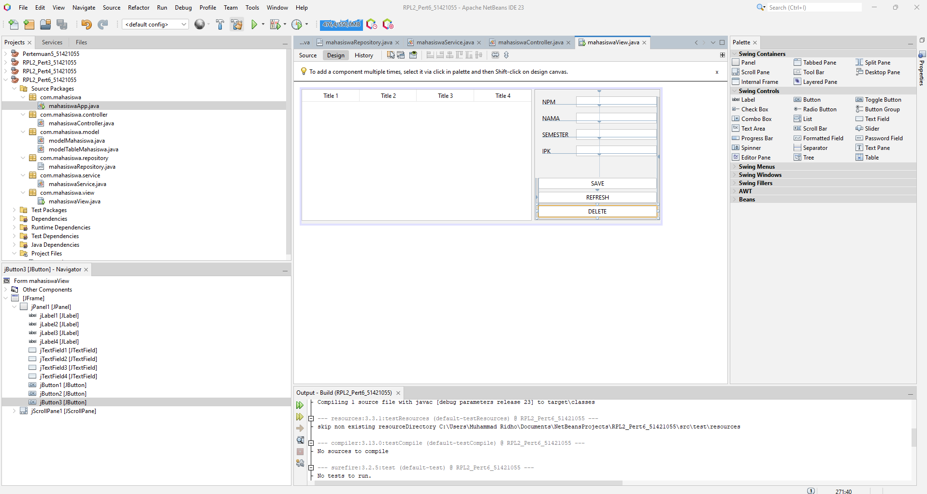

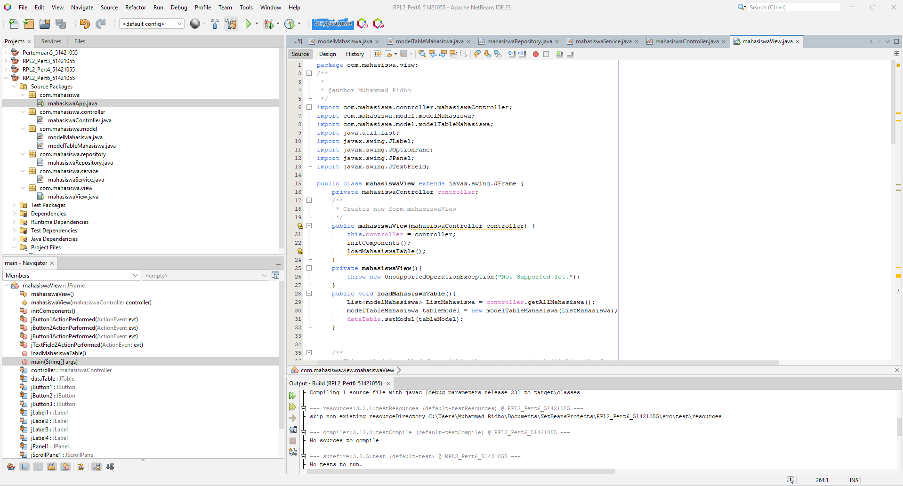

*Sourcecode:*

*package com.mahasiswa.view;*

*/\*\**

*\**

*\* @author Muhammad Ridho*

*\*/*

*import com.mahasiswa.controller.mahasiswaController;*

*import com.mahasiswa.model.modelMahasiswa;*

*import com.mahasiswa.model.modelTableMahasiswa;*

*import java.util.List;*

*import javax.swing.JLabel;*

*import javax.swing.JOptionPane;*

*import javax.swing.JPanel;*

*import javax.swing.JTextField;*

*public class mahasiswaView extends javax.swing.JFrame {*

*private mahasiswaController controller;*

*/\*\**

*\* Creates new form mahasiswaView*

*\*/*

*public mahasiswaView(mahasiswaController controller) {*

*this.controller = controller;*

*initComponents();*

*loadMahasiswaTable();*

*}*

*private mahasiswaView(){*

*throw new UnsupportedOperationException("Not Supported Yet.");*

*}*

*public void loadMahasiswaTable(){*

*List<modelMahasiswa> ListMahasiswa = controller.getAllMahasiswa();*

*modelTableMahasiswa tableModel = new modelTableMahasiswa(ListMahasiswa);*

*dataTable.setModel(tableModel);*

*}*

*@SuppressWarnings("unchecked")*

*private void jButton2ActionPerformed(java.awt.event.ActionEvent evt) {*

*loadMahasiswaTable();*

*}*

*private void jTextField2ActionPerformed(java.awt.event.ActionEvent evt) {*

*}*

*private void jButton1ActionPerformed(java.awt.event.ActionEvent evt) {*

*String npm = jTextField1.getText();*

*String nama = jTextField2.getText();*

*int semester = Integer.parseInt(jTextField3.getText());*

*float ipk = Float.parseFloat(jTextField4.getText());*

*modelMahasiswa mahasiswa = new modelMahasiswa(0, npm, nama, semester, ipk);*

*System.out.println(mahasiswa.getIpk());*

*System.out.println(mahasiswa.getNama());*

*System.out.println(mahasiswa.getSemester());*

*System.out.println(mahasiswa.getNpm());*

*controller.addMahasiswa(mahasiswa);*

*loadMahasiswaTable();*

*}*

*private void jButton3ActionPerformed(java.awt.event.ActionEvent evt) {*

*JTextField idField = new JTextField(10);*

*JPanel panel = new JPanel();*

*panel.add(new JLabel("Masukkan ID yang Ingin Dihapus : "));*

*panel.add(idField);*

*int result = JOptionPane.showConfirmDialog(null, panel, "Hapus Mahasiswa", JOptionPane.OK_CANCEL_OPTION, JOptionPane.PLAIN_MESSAGE);*

*if(result == JOptionPane.OK_OPTION) {*

*try{*

*int id = Integer.parseInt(idField.getText());*

*controller.deleteMahasiswa(id);*

*JOptionPane.showMessageDialog(null, "Data Berhasil dihapus", "Sukses", JOptionPane.INFORMATION_MESSAGE);*

*}catch (NumberFormatException e){*

*JOptionPane.showMessageDialog(null,"ID harus berupa angka" , "Error", JOptionPane.ERROR_MESSAGE);*

*}*

*}*

*}*

*/\*\**

*\* @param args the command line arguments*

*\*/*

*public static void main(String args[]) {*

*/* Set the Nimbus look and feel */*

*//<editor-fold defaultstate="collapsed" desc=" Look and feel setting code (optional) ">*

*/* If Nimbus (introduced in Java SE 6) is not available, stay with the default look and feel.*

*\* For details see http://download.oracle.com/javase/tutorial/uiswing/lookandfeel/plaf.html*

*\*/*

*try {*

*for (javax.swing.UIManager.LookAndFeelInfo info : javax.swing.UIManager.getInstalledLookAndFeels()) {*

*if ("Nimbus".equals(info.getName())) {*

*javax.swing.UIManager.setLookAndFeel(info.getClassName());*

*break;*

*}*

*}*

*} catch (ClassNotFoundException ex) {*

*java.util.logging.Logger.getLogger(mahasiswaView.class.getName()).log(java.util.logging.Level.SEVERE, null, ex);*

*} catch (InstantiationException ex) {*

*java.util.logging.Logger.getLogger(mahasiswaView.class.getName()).log(java.util.logging.Level.SEVERE, null, ex);*

*} catch (IllegalAccessException ex) {*

*java.util.logging.Logger.getLogger(mahasiswaView.class.getName()).log(java.util.logging.Level.SEVERE, null, ex);*

*} catch (javax.swing.UnsupportedLookAndFeelException ex) {*

*java.util.logging.Logger.getLogger(mahasiswaView.class.getName()).log(java.util.logging.Level.SEVERE, null, ex);*

*}*

*//</editor-fold>*

*/* Create and display the form */*

*java.awt.EventQueue.invokeLater(new Runnable() {*

*public void run() {*

*new mahasiswaView().setVisible(true);*

*}*

*});*

*}*

**mahasiswaApp.java**

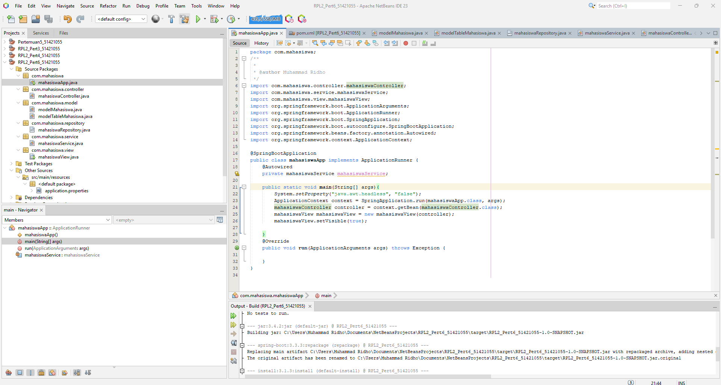

*Sourcecode:*

*package com.mahasiswa;*

*/\*\**

*\**

*\* @author Muhammad Ridho*

*\*/*

*import com.mahasiswa.controller.mahasiswaController;*

*import com.mahasiswa.service.mahasiswaService;*

*import com.mahasiswa.view.mahasiswaView;*

*import org.springframework.boot.ApplicationArguments;*

*import org.springframework.boot.ApplicationRunner;*

*import org.springframework.boot.SpringApplication;*

*import org.springframework.boot.autoconfigure.SpringBootApplication;*

*import org.springframework.beans.factory.annotation.Autowired;*

*import org.springframework.context.ApplicationContext;*

*@SpringBootApplication*

*public class mahasiswaApp implements ApplicationRunner {*

*@Autowired*

*private mahasiswaService mahasiswaService;*

*public static void main(String[] args){*

*System.setProperty("java.awt.headless", "false");*

*ApplicationContext context = SpringApplication.run(mahasiswaApp.class, args);*

*mahasiswaController controller = context.getBean(mahasiswaController.class);*

*mahasiswaView mahasiswaView = new mahasiswaView(controller);*

*mahasiswaView.setVisible(true);*

*}*

*@Override*

*public void run(ApplicationArguments args) throws Exception {*

*}*

*}*

**mahasiswa.properties**

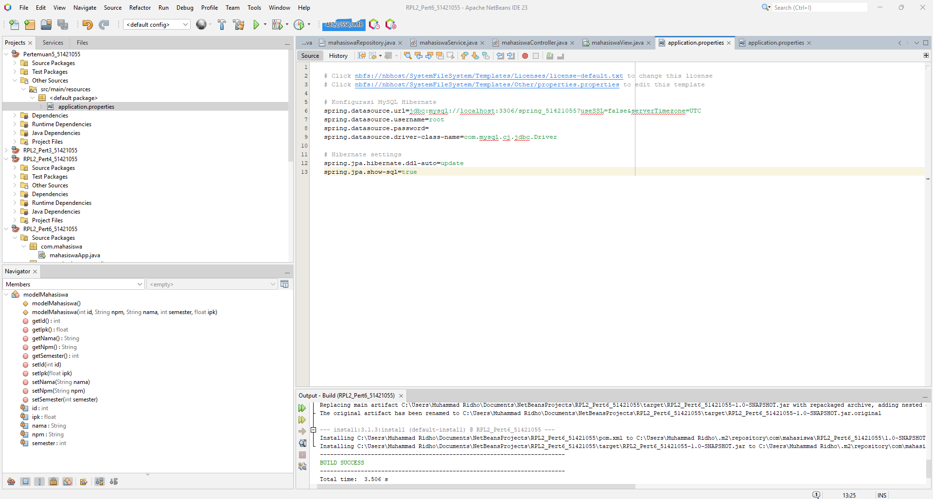

*Sourcecode:*

*# Click nbfs://nbhost/SystemFileSystem/Templates/Licenses/license-default.txt to change this license*

*# Click nbfs://nbhost/SystemFileSystem/Templates/Other/properties.properties to edit this template*

*# Konfigurasi MySQL Hibernate*

*spring.datasource.url=jdbc:mysql://localhost:3306/pertemuan6_db?useSSL=false&serverTimezone=UTC*

*spring.datasource.username=root*

*spring.datasource.password=*

*spring.datasource.driver-class-name=com.mysql.cj.jdbc.Driver*

*# Hibernate settings*

*spring.jpa.hibernate.ddl-auto=update*

*spring.jpa.show-sql=true*

**Output:**

